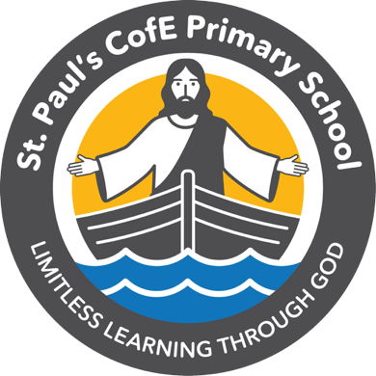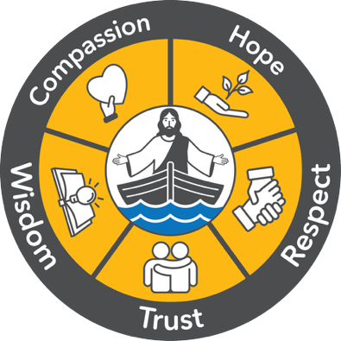

St. Paul’s CofE Primary School

MUSIC DEVELOPMENT PLAN SUMMARY 2026-27

Our Vision:

With God, there is no limit to what you can do, there is no obstacle you can’t overcome, through him all things are possible. (Matthew 19:26)

Overview 2026-27
Detail | Information
Academic year that this summary covers | 2026-2027
Date this summary was published | September 2026
Date this summary will be reviewed | September 2027
Name of the school music lead | Helen Hill
Name of school leadership team member with responsibility for music (if different) | Connor Rooney
Name of local music hub | Bury
Name of other music education organisation(s) (if partnership in place) | Create Music (Bury Music Service)

This is a summary of how our school delivers music education to all our pupils across three areas – curriculum music, co-curricular provision and musical experiences – and what changes we are planning in future years. This information is to help pupils and parents or carers understand what our school offers and who we work with to support our pupils’ music education.

Part A: Curriculum music
This is about what we teach in lesson time, how much time is spent teaching music and any music qualifications or awards that pupils can achieve.
Music is taught in class every week and is informed by the model music curriculum (March 2021) and supported by Bury Music service who deliver lessons for all children fortnightly. Children will perform, listen and analyse critically, sing, improvise and compose music and understand the musical elements as building blocks with music. Lessons are a minimum of 30 minutes (Reception and KS1) and 45 minutes (KS2) and are taught by class teachers alongside music specialists. Planning is based on procedural, declarative and tacit knowledge with incremental steps in learning.
In EYFS music is delivered through holistic practice as an integral part of early development. Music is planned for across the 4 Musical areas: Hearing & Listening, Vocalising & Singing, Moving & Dancing and Exploring 7 playing. Invitations to engage with sound are planned for every day and singing is integrated throughout the day. Each week there is a focused taught music sessions.
The learning in KS1 and KS2 is further supplemented by regular opportunities to sing through collective worship and curriculum linked singing. Through the taught music curriculum children develop their playing with increasing accuracy, fluency, control and expression. Listening develops aural memory and children develop an understanding of the history of music through using timelines to place and sequence pieces of music and identifying links between them.
Across the Primary phase, children have opportunities to learn instruments as part of the curriculum. This learning culminates in performances for the whole school termly.

Part B: Extra-curricular music
This is about opportunities for pupils to sing and play music, outside of lesson time, including choirs, ensembles and bands, and how pupils can make progress in music beyond the core curriculum.
At St Paul’s Primary School, we currently offer individual and small groups lessons through Create Music Service. Teachers visit the school and teach children in a dedicated space.
We have a thriving School Choir made up of children from Key Stage 1 and 2 run by Mrs Hill.
Individual and small group lessons are funded by parents, however for those children eligible for looked after children and pupil premium these lessons are subsidised by school.
We work closely with Bury Music Service to ensure we can offer the best possible music opportunities for our children. If you have an enquiry regarding instrumental lessons on offer, please visit the website: https://burymusic.co.uk

Part C: Musical experiences and events
This is about all the other musical events and opportunities that we organise, such as singing in assembly, concerts and shows, and trips to professional concerts.
Children will have the opportunity to perform or experience high quality music this academic year. Please see below for a list of these opportunities:
- Year 6 perform a musical show for parents and the wider community.
- All children from Reception to Year 6 perform at Christmas.
- School choir perform for different audiences during the year, including singing for a local care home and for parents, Bury Market etc.
- All classes performing to an audience following their learning of an instrument.
- Attending Bury Grammar and Halle to listen to an orchestral performance.

In the future
This is about what the school is planning for subsequent years.
In future years, our Music development Plan aims to achieve the following:
- Introduction of a wider range of instruments on offer for small group or individual lessons.
- Widen the number of songs which reflect different cultures and languages.
- Introduction of further whole-class ensemble projects delivered by a music specialist.
- Further enhance performance opportunities for young musicians throughout the school year.
- Further deepen the engagement in extra-curricular music for Pupil premium and SEND children.
- Develop staff expertise in delivering high quality music lessons through CPD from Bury Music Service.

Further information (optional)
The Department for Education publishes a guide for parents and young people on how they can get involved in music in and out of school, and where you can go to for support beyond the school.

