

St. Paul’s CofE Primary School

BEHAVIOUR POLICY

Our Vision:

With God, there is no limit to what you can do, there is no obstacle you can’t overcome, through him all things are possible. (Matthew 19:26)

Approved by: LAB | Date: November 2024
Last reviewed on: 2.9.2026
Next review due by: 01.09.2027

Version control | Amendment / change made | Amended by | Date
1 |  | Sarah Oxley | 1.11.2024
2 | Additional detail added to behaviour pathway. | Komal Asani | 01.09.2025
3 | Appendices changed | Connor Rooney | 14.7.2026

CONTENTS
- PRINCIPLES
- BEHAVIOUR FOR LEARNING
- SANCTIONS
- STRATEGIES
- SEARCHING PUPILS
- POSITIVE HANDLING AND REASONABLE FORCE
- EQUALITY
- PARENTS
- ACCOUNTABILITY
- GOVERNORS
- APPENDICES

- PRINCIPLES

Everyone is expected to maintain the highest standards of personal conduct, to accept responsibility for their behaviour and encourage others to do the same. Our vision for education for all pupils at St. Paul’s, is that pupils:
- develop the wisdom, knowledge and skills to enable them to flourish in the next stages of their education
- develop their understanding of hope and aspiration and how this can be fulfilled
- value the worth of each person within our school community, treating them with dignity and respect
- develop the qualities of life which will help them contribute responsibly to their communities

With these in mind, we are committed to creating an environment where exemplary behaviour is at the heart of productive learning.

We aim to:
- Provide a safe, comfortable and caring environment where optimum learning takes place
- Provide clear guidance for children, staff and parents of expected levels of behaviour
- Use a consistent and calm approach
- Ensure all adults take responsibility for managing behaviour and follow-up incidents personally
- Ensure all adults use consistent language to promote positive behaviour and use restorative approaches instead of punishments

Purpose of the behaviour policy: To provide simple, practical procedures for staff and children that:
- Foster the belief that there are no ‘bad’ children, just ‘bad choices’
- Encourage children to recognise that they can and should make ‘good’ choices
- Recognise individual behavioural norms and respond appropriately
- Promote self-esteem and self-discipline
- Teach appropriate behaviour through positive intervention

All staff must:
- Smile and be welcoming to all children
- Be at the playground line, or at the front of the classroom, at the start of the day
- Be in the classroom, ready for each session
- Always pick up on children who are failing to meet expectations
- Always redirect children by referring to our school values

The Headteacher and the Senior Leadership Team must:
- Be a visible presence around the school
- Regularly celebrate staff and children whose efforts go above and beyond expectations
- Encourage use of positive praise, phone calls/texts/notes home/certificates/stickers
- Ensure staff training needs are identified and met
- Use behaviour records to target and assess interventions
- Support teachers in managing children with more complex or challenging behaviours

Members of staff who manage behaviour well:
- Deliberately and persistently catch children doing the right thing and praise them in front of others
- Know their classes well but also develop positive relationships with all children
- Relentlessly work to build mutual respect
- Remain calm and keep their emotion for when it is most appreciated by children
- Demonstrate unconditional care and compassion

Children want teachers to:
- Give them a ‘fresh start’ every lesson
- Help them learn and feel confident
- Be just and fair
- Have a sense of humour

BEHAVIOUR FOR LEARNING
We recognise that clear structure of predictable outcomes has the best impact on behaviour. Our policy is based on the work of Paul Dix and his book ‘When the adults change, everything changes’. Good behaviour is recognised sincerely rather than just rewarded. Children are praised publicly and reminded in private.

‘’When people talk about behaviour, they obsessively search for the instant solution. Some peddle magic dust or ‘behaviour systems’ that glisten yet quickly fade. Others relentlessly scream for a bigger stick to beat children down with. Both extremes harbour an irresistible idea that there is a short cut to changing behaviour. They sell the lie that you can provoke sustained behavioural change in others without doing much hard work yourself. The truth is that there is no alternative to the hard work: building relationships with those who would rather not, resetting expectations with those who trample them, being relentlessly positive and sustaining a poker face when confronted with challenging behaviour.’’

Paul Dix, Pivotal Education

Our school has three simple rules: ‘Be Ready, Be Respectful and Be Safe’.

Our three simple school rules are further explored and explicitly taught in class, assemblies and other school experiences.

For example, they might be expanded as follows:

Be ready
- I will help myself and others to learn by being in the right place, with the right equipment and ready to listen and complete my work.

Be respectful
- I will listen and talk politely to adults and other pupils; and look after equipment and other people’s possessions.

Be safe
- I will be kind and look after myself and others, following appropriate instructions from adults.

However, we also understand that for some children, following our behaviour expectations are beyond their current developmental level. In this case, these children will have access to bespoke positive behaviour plans, which may include carefully targeted sanctions and rewards to reinforce positive behaviour.

We understand that a common and consistent use of language around behaviour is essential in creating clear boundaries for learning how to behave. Phrases such as ‘kicked off’ or ‘screaming fit’ are unhelpful in these instances and adults should always remain professional and calm. Conversations should follow a script, and behaviours should be discussed as the behaviours they are and not be personal to the child. See appendix 2

Most conversations around behaviour would normally be conducted, in the first instance, by the class teacher. Incidents are then logged on Arbor using the behaviour pathway as a guide.

SANCTIONS
Sanctions should always:
- make it clear that unacceptable behaviour affects others and is a serious offence against the school community
- avoid being applied to a whole group for the activities of individuals
- be consistently applied by all staff to help to ensure that children and staff always feel supported and secure

Sanctions need to be in proportion to the offence. It should also be made very clear that it is the behaviour that is unacceptable, and any sanction should address this, not be made personal to the child.

Our Behaviour Pathway (See Appendix 1)
- Reminder (3 rules- Be Ready. Be Respectful, Be Safe)
- Warning (amber notification - privately if possible. Use 30 second scripted intervention (see

Appendix 2)

Consequence (recorded as red notification on CPOMS and message sent via Arbor to parents. Restorative conversation with teacher after the lesson – see Appendix 3)

If required:
- Space to cool off/calming time in class/in another class/in another designated space
- Follow up/restorative conversation. Should an adult feel, using their professional judgement, that a senior member of staff needs to be part of the follow up/restorative conversation then the following guidelines should be used:
- Pupil is taken to a member of the Leadership Team (SLT), Deputy Headteacher or the Headteacher (usually in that order)
- Parents contacted
- Parents called to school
- Internal Exclusion
- Short Fixed Term Exclusion (1-2 days)
- Longer Fixed Term Exclusion (3-5 days)
- Permanent Exclusion

- STRATEGIES
At St. Paul’s, adults apply the following principles in all interactions with pupils:
  - IDENTIFY the behaviour we expect
  - Explicitly TEACH behaviour
  - MODEL the behaviour we are expecting
  - PRACTISE behaviour
  - NOTICE excellent behaviour
  - CREATE conditions for excellent behaviour Language around Behaviour

Visible Consistencies:
- Daily meet and greet - on time at 8:45am
- Persistently catching children doing the right thing
- Picking up on children who are failing to meet expectations
- Praising in public
- Reminding in private
- Consistent language

Over and Above Recognition:
- First attention best conduct- praise those doing the best before paying attention to those who are not.
- House points (how many and what for, how are they recorded, termly treats.
- 3 certificates (1 child for the vision)
- Show off good work to other key adults
- Communicate positive messages to parents/carers (ParentHub)
- Add to newsletter (nominate a child to take photos)
- Positive praise/recognition
- Top Table – see rota created
- Turn it to learn it – taught behaviour strategy of that week- targets for recognition boards.

The Power to discipline beyond the School Gate:
Whether to discipline children regarding behaviour outside the school gates is at the Headteacher’s discretion (or at the discretion of staff authorised by the Headteacher) in conjunction with DfE guidance. If sanctions are deemed necessary, they will be applied in line with the Behaviour Policy. The Governing Body strongly believes that for pupils of primary school age it is their parents’ responsibility to ensure that they are well-behaved outside school hours and, on their way, to and from school.

SEARCHING PUPILS
The Headteacher and staff authorised by the Headteacher have the power to search pupils or their possessions, without consent, where they suspect the pupil has weapons, alcohol, illegal and legal drugs and stolen items. If a search is thought necessary, this is always carried out by two members of staff. The Headteacher and staff authorised by them have a statutory power to search pupils or their possessions without consent if they have reasonable grounds to suspect:
- Knives or weapons
- Alcohol
- Illegal drugs
- Stolen items
- Tobacco and cigarette papers
- Fireworks
- Pornographic images
- Any article that the member of staff reasonably suspects has been, or is likely to be used to:
- Commit an offence
- Cause injury or damage
- Any item banned by school rules.

School staff can seize any prohibited item found as a result of a search. They can also seize any item, however harmful or detrimental to school discipline. Staff carrying out a search should have a witness unless there is risk of serious harm if not conducted immediately or where it is not reasonably practicable to summon another member of staff.

POSITIVE HANDING AND REASONABLE FORCE
St. Paul’s CE Primary School makes use of the DfE guidance: Use of Restrictive Intervention (2026). Any force used should always be the minimum needed to achieve the desired result. Key staff at St. Paul’s Primary School have had the appropriate Team Teach training to use positive handing, force and restraint appropriately and safely and are certified to use this approach, although we would only resort to this in extreme circumstances where a child or adult is in danger. All incidents which require the use of positive handling or restraint will be reported to a member of the Senior Leadership Team and a log of incidents is kept on CPOMS. Parents will be informed of any incident where force or restraint has been used on their child.

Procedure in the event of a child running away from an adult:
If children run out of class or the building and do not respond to requests to return, parents will be called and asked to come to school. Staff will not chase children as this may cause them to run into further danger but will observe from a distance and keep in contact with the school via mobile phones. If a child leaves the school site, the police will be contacted for the safety and wellbeing of the pupil.

EQUALITY
The school expects all members of the community to adhere to this policy consistently, fairly and without prejudice. The school adheres to the Equality Act 2010 in reference to this policy. No member of staff will discriminate against, harass or victimise children because of their: sex; race; disability; age; religion or belief; sexual orientation; or because of gender reassignment.

For children with SEND, this includes a duty to make reasonable adjustments to policies and practices.
- Reasonable adjustments for pupils will be recorded on an individual behaviour plan or an SEN pupil profile outlining the provision needed for a particular individual. This may include the development of behaviour modification strategies with the advice of external agencies e.g. Educational Psychologist, behaviour consultant, Social Care or CAMHS.
- A reduced timetable may be put in place in line with guidance from the Borough. Children on reduced timetables will be reported to the Governors and the Primary objective is for these children to return to full time provision as soon as possible.
- A risk assessment based on prior behaviours may result in the pupils being restricted from some activities such e.g. attending school trips but only if the behaviour is dangerous.

Supporting pupils with SEND
Expectations for managing behaviour of pupils with SEND:
For pupils with SEND their behaviour is often a form of communication and the meaning behind this communication might not always be clear. Children who are showing negative behaviours might not be doing this on purpose and might find it difficult to communicate their needs or feelings in a calmer or clearer way. It might be because they are feeling anxious and are seeking reassurance. It is important that for these pupils, we look at their behaviour as part of them and something that we can help them understand and manage.

Using the zones of regulation approach will help identify the child’s feelings, triggers and appropriate way to respond. All adults, who will be teaching a group of pupils, are personally responsible for knowing a child’s individual needs before teaching them. They should ensure they have accessed the child’s provision map. Teachers need to use behaviour plans to understand what works and what doesn’t work for that child. For example: If a child has ADHD and possibly has difficulty keeping calm and focusing, taking away their playtime could be detrimental to their behaviour for the rest of the day as they require physical time. There would have to be other steps/approaches in place for that child that should be followed.

Behaviour scripts and systems can be adapted to suit the needs of individual pupils. If a child does not respond to policy systems, evaluate why and what would work better for that child. Their individual targets and adapted expectations for behaviour should be in their behaviour plan which will be monitored by the SENDCo. A child’s triggers for negative behaviour need to be in their plan so that everyone can be aware of these.

Teachers who are preparing their classes to be covered by someone else must ensure behaviour plans and personalised timetables are communicated with covering teachers so the approach to managing their behaviour is always consistent.

Behaviours that children with SEND that might exhibit to try and communicate with you:
- work avoidance- this might be because they have not understood instructions or require reassurance that they are doing the right thing.
- focusing their attention on the adults- following and asking repeated questions. This might be for more reassurance that they are doing the right thing or that they are liked
- calling out- this might be so they feel noticed and to also feel reassured

PARENT
If a parent is not satisfied with the manner in which their child has been sanctioned, then they should take the following action:
- Contact the child’s teacher – either in person or call the school office
- Arrange an appointment with the teacher
- Arrange an appointment to see the Deputy Headteacher or Headteacher.
If, after talking with teachers and/or the Headteacher, parents are still not satisfied then they should contact the Chair of Governors.

ACCOUNTABILITY
It is the responsibility of the Head Teacher and Senior Leadership Team to:
- Provide a framework for consistent behaviour monitoring in school.
- Ensure that all staff are following the policy and review the policy accordingly.
- Issue fixed-term and/or permanent exclusions to individual pupils.

GOVERNORS
The Local Advisory Board has the responsibility of setting down this policy and establishing overall aims on standards of discipline and behaviour, and of reviewing the effectiveness of this policy. The governors support the Head Teacher in implementing this policy.

APPENDIX 1
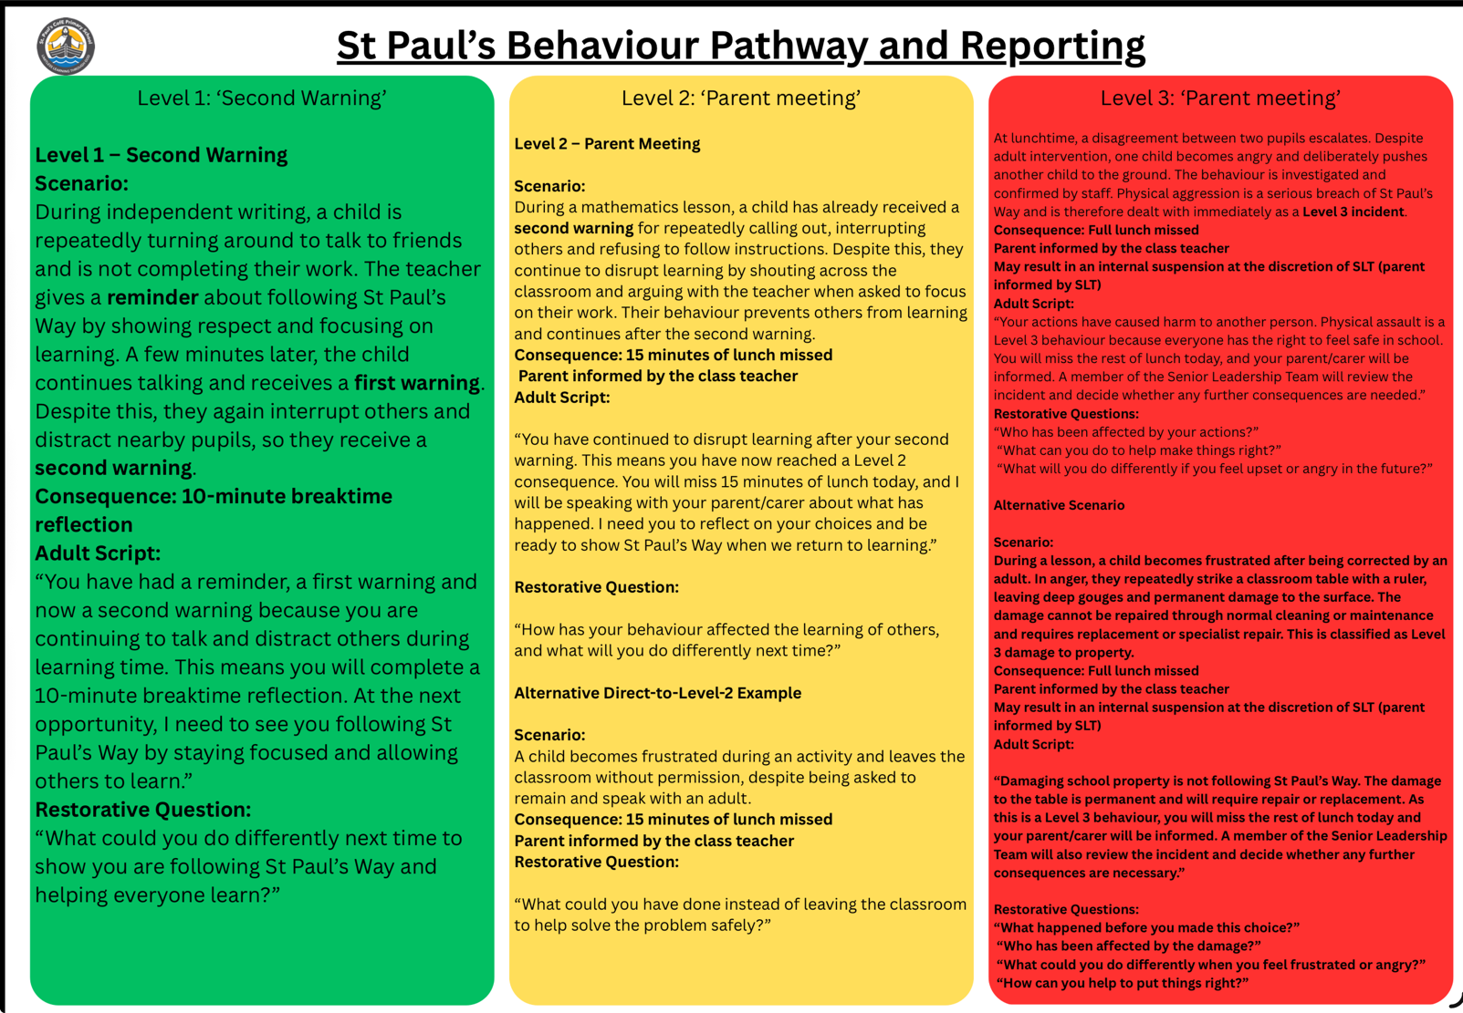
ST. PAUL’S BEHAVIOUR PATHWAY

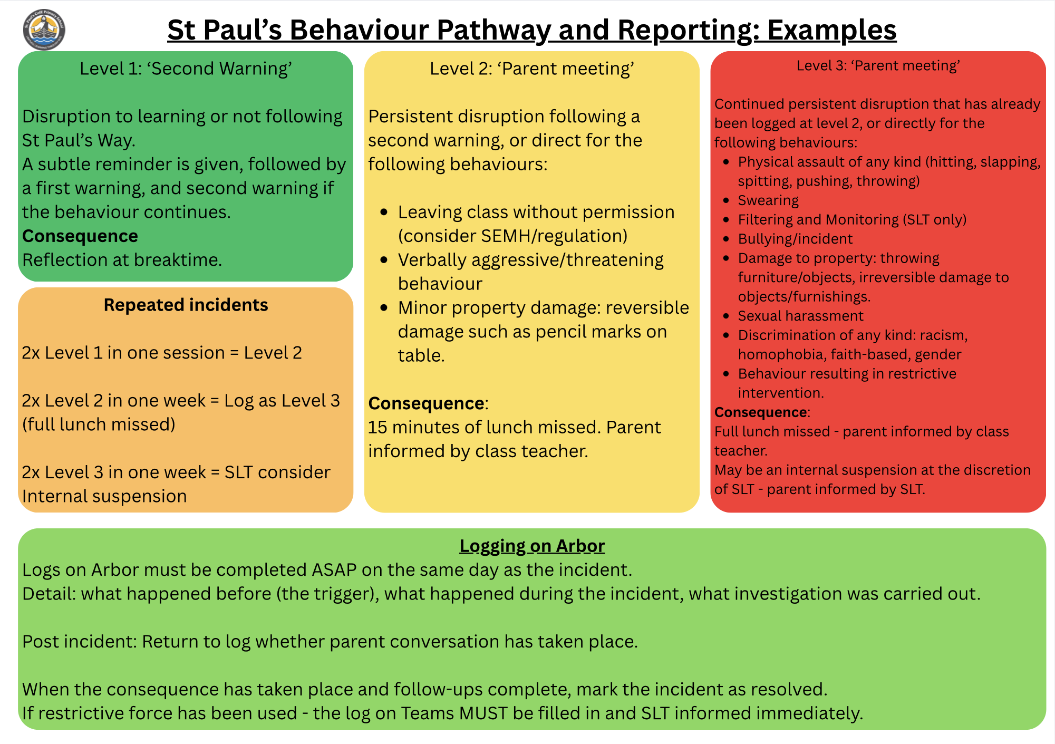

APPENDIX 2
- SECOND SCRIPTED INTERVENTION
  - I have noticed that you are (having trouble getting started, wandering around, playing with apparatus) right now.
  - You are not showing our. (3 rules)
  - You have chosen to….
  - Because of that you need to…. (refer to action to support behaviour e.g move to another table, complete learning at another time)
  - Do you remember when you (refer to previous positive behaviour)
  - That is who I need to see today.
  - Thank you for listening.

APPENDIX 3

RESTORATIVE QUESTIONS

As part of our approaches to managing behaviour, adults should hold a restorative conversation with any child who reaches stage 3. This conversation will normally take place during lunch time duty. Sometimes it may include other adults or children.

Staff will have a script for the restorative conversation that they feel comfortable with. The questions may include:

    - What happened?
    - What were you thinking at the time?
    - What have you thought since?
    - How did this make people feel?
    - Who has been affected?
    - How have they been affected?
    - What should we do to put things right?
    - How can we do things differently in the future?

APPENDIX 4

REFLECTION CARDS


KS2 REFLECTION CARD



NAME |  | AMBER |  | RED

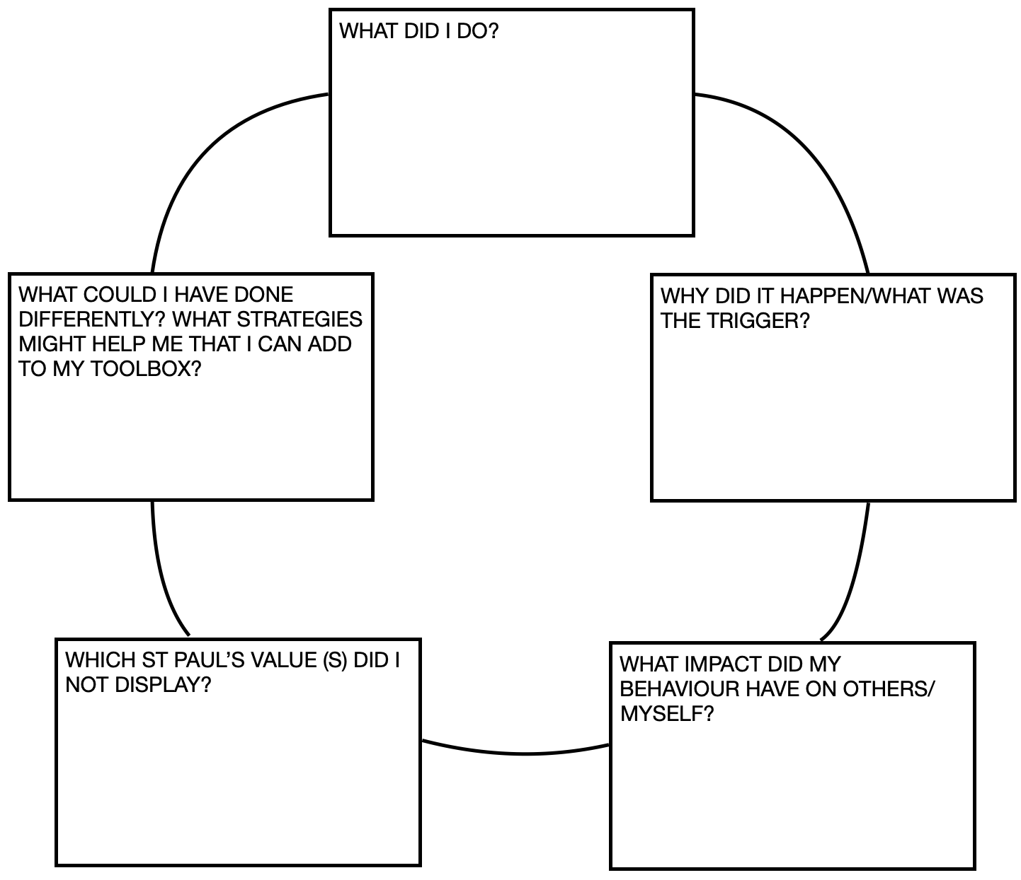

KS1 REFLECTION CARD

NAME |  | AMBER |  | RED

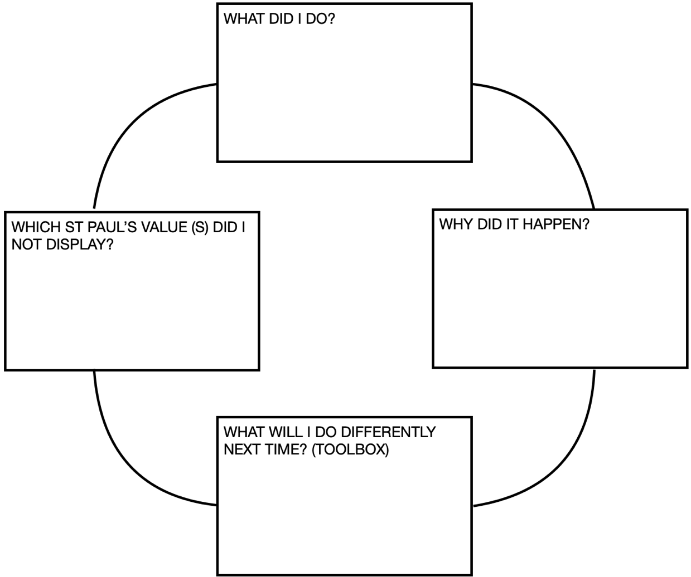

APPENDIX 5
SUSPENSION LETTER
